ASG 4.2

Pat Rafter

Redesign the following table (COURSE_INSTRUCTOR) using a step by step approach. Start from the 1NF normal form. First, fix all possible 1NF violations,  next 2NF violations, and finally move to 3NF violations.

The primary keys are underlined. See the example in Section 4.4 of the course website.

COURSE_ INSTRUCTOR (CourseNo, InstructorID, Semester, Section, DepartHead, ComputerNeeded, Classrom, MaxCap)

create table COURSE_INSTRUCTOR (

CourseNo CHAR(10),

InstructorID INT,  
Semester CHAR(20),   
Section INT,  
DepartHead INT,  
ComputerNeeded SMALLINT,  
Classroom CHAR(20),  
MaxCap INT,  
primary key(CourseNo, InstructorID, Semester, Section)  
);

The followings are the dependencies in the table ( X-> Y means column X determines column Y)

CourseNo -> ComputersNeeded

InstructorID -> DepartHead

Classrom ->MaxCap

**Notes**:

1. In this exercise you may want to rename your tables with suffixes as 1NF, 2NF, and 3NF after each step because you cannot create tables with the same name (eg., COURSE2NF after fixing 2NF problems). This also requires renaming and updating the resulting primary AND foreign keys. Alternatively, you can add drop statements in the beginning of the script.  Otherwise, you will have errors.
2. Make sure that your scripts will work correctly in your database account after each step.

**Required Steps:**

A) What are the possible 1NF violations in this problem?  If there is any, fix them and provide the script of the new design. You can assume anything as long as you justify it in this step. Clarify your justifications.

I only found one first normal form violation it was if the teacher is teaching the course but meets in different classrooms throughout the week. So what I would do is create another table for days of the week and location.

B) Start from the design in part A. What will be the tables and their columns after fixing all 2NF violations? Provide the ER-diagram and SQL script after fixing all 2NF violations. Show that your SQL script works correctly in your database account.

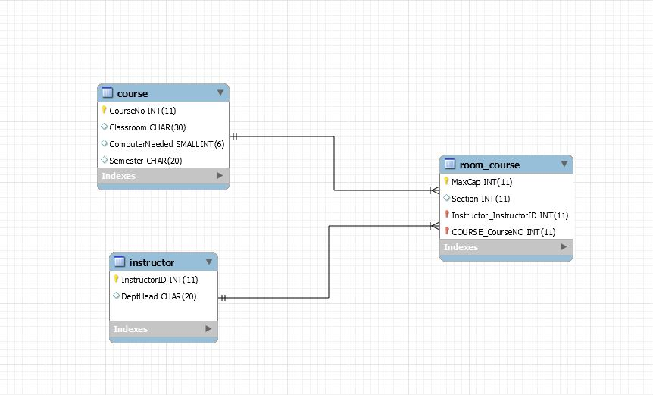

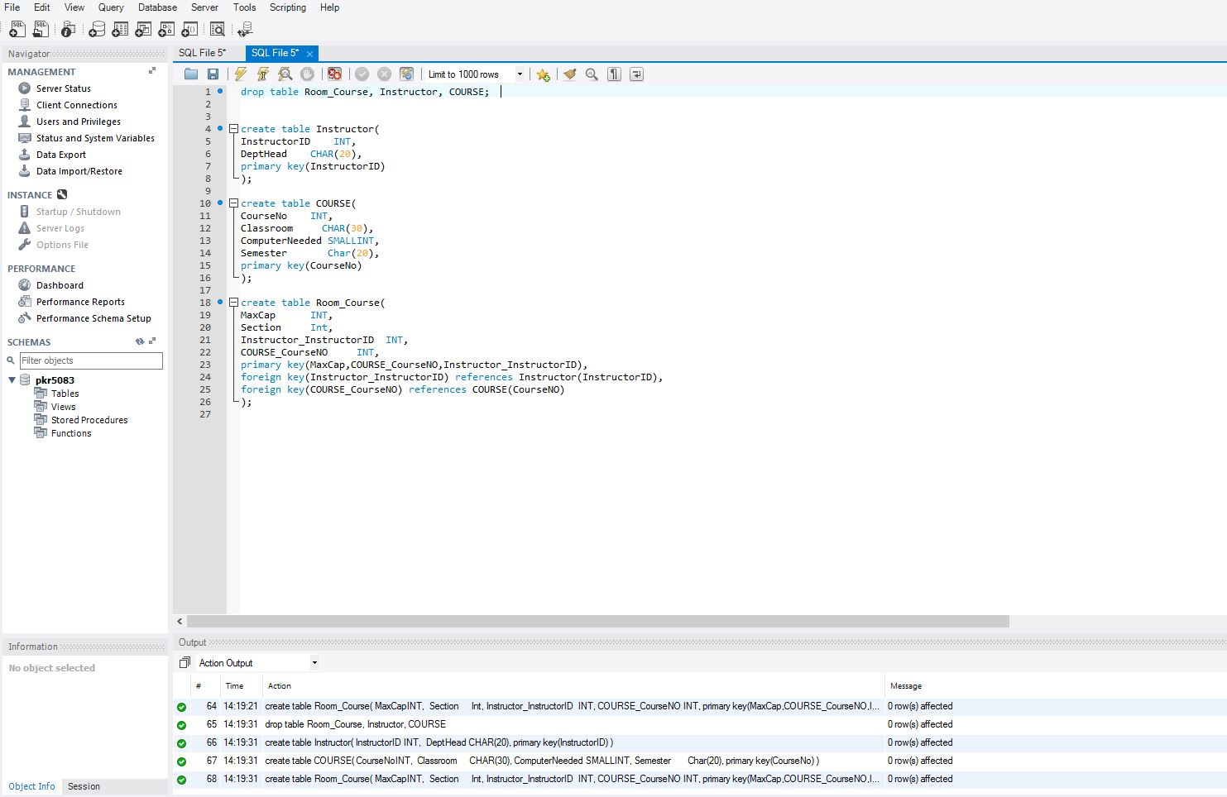

C) Start from the design in part B. What will be tables and their columns  after fixing all 3NF violations?  Create the final ER-diagram and the script after fixing all 3F violations.  Show that your SQL script works correctly in your database account.

